Amber Kuss
2/4/10

GEOG 603: Introduction to GIS

Lab 1: Exploring ArcGIS Desktop

(20 points)

? Question 1-1 (2 points): What type of data does SF_planning_districts look like – raster or vector?

The SF planning districts file is vector data.

? Question 1-2 (2 points): Similarly, what type of data is sf_elevation – raster or vector?

The SF elevation file is raster data.

? Question 1-3 (2 points): What type of data is sf_planning – raster or vector?

The SF planning file is raster data.

? Question 1-4 (2 points): Now you have seen that the planning districts in San Francisco can be modeled in both raster and vector format. Which format is better and why?

Vector format would be the preferred type of data to use for planning districts. Vector formatting is best for data with human-made definite boundaries. This is also the best type of data for graphic output, which is the reason for using this data.

? Question 1-5 (2 points): What are the bounding coordinates (both decimal degrees and projected coordinates) of the parks shapefile (Hint: it should be under the Spatial tab)?

The bounding coordinates for the parks shapefile are:

In decimal degrees
West: -122.517358
East: -122.369111
North: 37.811523
South: 37.707585
In projected or local coordinates
Left: 542542.098383
Right: 555532.678042
Top: 4185013.476491
Bottom: 4173558.521067

? Question 1-6 (3 points): Is the affordable housing project at Folsom and Columbia Square within walking distance of Mission street? What is the “on-the-road” distance (NOT “as-the-crow-flies”)?

The housing unit located on the corner of Folsom and Columbia Square is just within walking distance if you make the measurement “as the crow flies”, at approximately 1,300 feet. When the measurement is taken “on-the-road” the measurement is approximately 1,500 feet, making it outside of the walking distance for the passengers.

? Question1-7 (2 points): Who built the projects? How many units are there?

The contractor for the housing units is Mercy Housing California, and there are 50 units in the building.

  - Question 1-8 (3 points) Insert the intro.png file here. Add text to describe what the figure shows.

This is a detailed map of San Francisco, and more specifically where the affordable housing units are located. The neighborhoods (planning districts) are labeled to represent a more comprehensive view of where the housing units are located. The map also shows the locations and names of the streets and the parks. The housing units are more densely distributed in the downtown/civic center area, south of Market, and in the western addition.
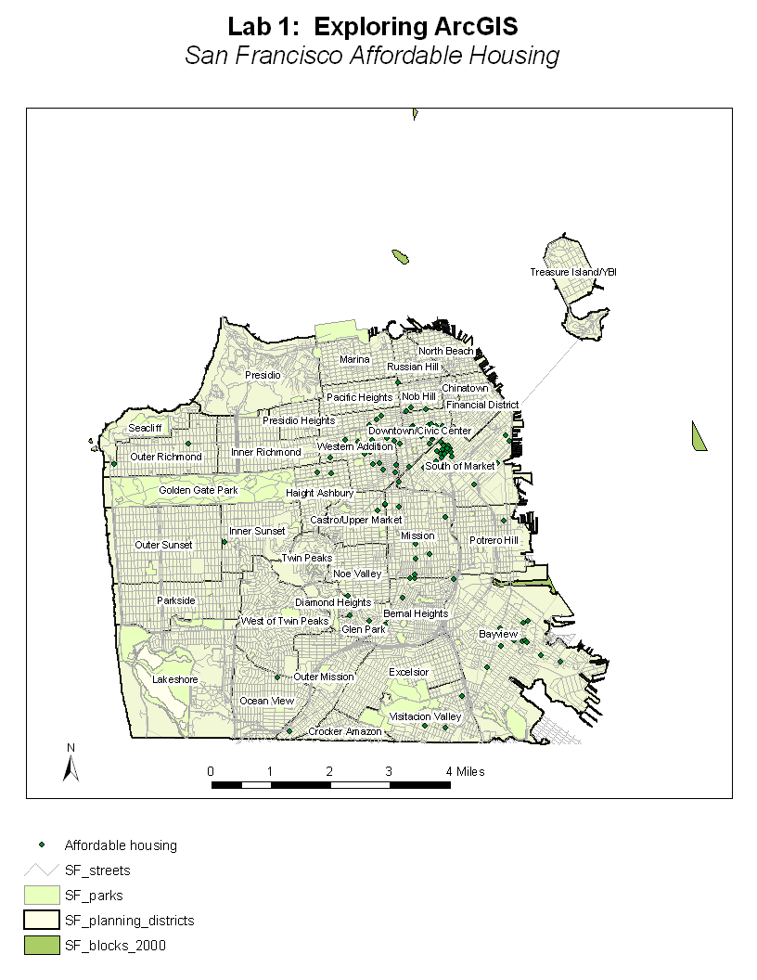

Your turn: (2 points)

In the yourturn folder of lab1, there is a WorldCities.mxd file which has two layers: countries and large metropolitan cities. Use what you’ve just learned to find how many cities have a population over 10 million (10000000) in year 2000? Where are they mainly located?

There are 18 cities that have a popultaion of over 10 million in the year 2000. Many of them are located in Asia, more specifically the continent of Asia.

